|  |  |
| --- | --- |
| **Name** | **Team Number** |
| Tomoki Koike | R06 |

AAE 251: Introduction to Aerospace Design

Assignment 1—Pitot Tubes

**Due Tuesday 22 January, 10:00 am on Blackboard**

**Instructions**

*This assignment has two parts—the derivation and application of Pitot tubes, and a Matlab assignment. Start now, or you will run out of time!*

*In part 1 of the assignment we will apply Bernoulli’s equation to understand how a Pitot tube works. You may find Anderson Chapter 4 very helpful, especially the examples.*

*In part 2 of the assignment we will write a code to reproduce the standard atmosphere. You will find the code useful in future Homeworks and your projects.*

*Write or type your answers into the appropriate boxes. Make sure you submit a single PDF, with responses to both parts on Blackboard. Your homework will be a handy study guide.*

|  |  |  |
| --- | --- | --- |
| Step Number | Points Possible | Points Earned |
| Step 1 | 8 |  |
| Step 2 | 6 |  |
| Step 3 | 22 |  |
| Step 4 | 8 |  |
| Matlab Assignment | 31 |  |
| Total | 75 |  |

# Step 0: Watching old TV

Here is a clear albeit old video discussing static and dynamic pressure, and, right at the end, pitot tubes. Take a look and marvel at how TV has improved and the laws of physics have remained true:

<https://youtu.be/dTXHoIs64hw>

# Step 1: Define Stagnation Pressure

When a stream of uniform velocity flows into a blunt body like an airfoil, the stream lines are as shown in Figure 1.

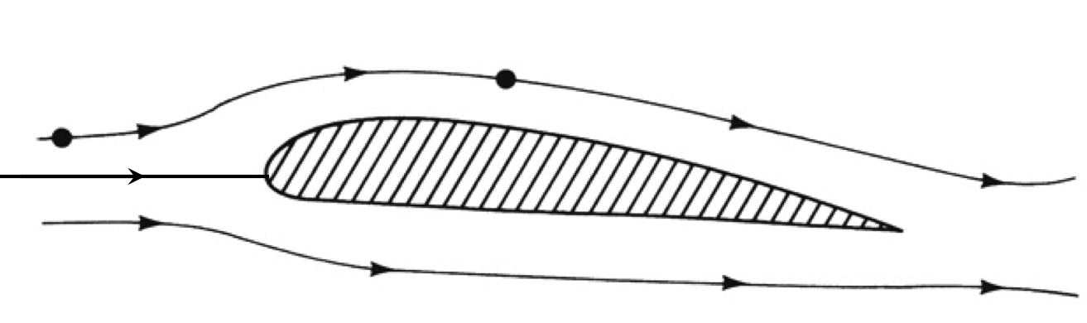

Figure 1: Stagnation Point

Some of the streamlines move over the airfoil, and some of them move under. But one streamline goes to the tip of the airfoil and then stops. At this *stagnation point*, the velocity is zero.

Let’s use the Bernoulli equation we derived in class to calculate the pressure at this point, or the *stagnation pressure*.

First, indicate your velocities and pressures on Figure 1: Designate a point upstream where the flow is undisturbed as having velocity and pressure , and the stagnation point as .

What assumption do we have to make about the fluid to apply Bernoulli’s equation?

Answer: In order to apply Bernoulli’s equation the fluid must be incompressible and the flow must be steady.

Now write down Bernoulli’s equation to relate these two pairs of values, and solve for the stagnation pressure:

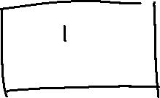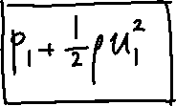

Answer: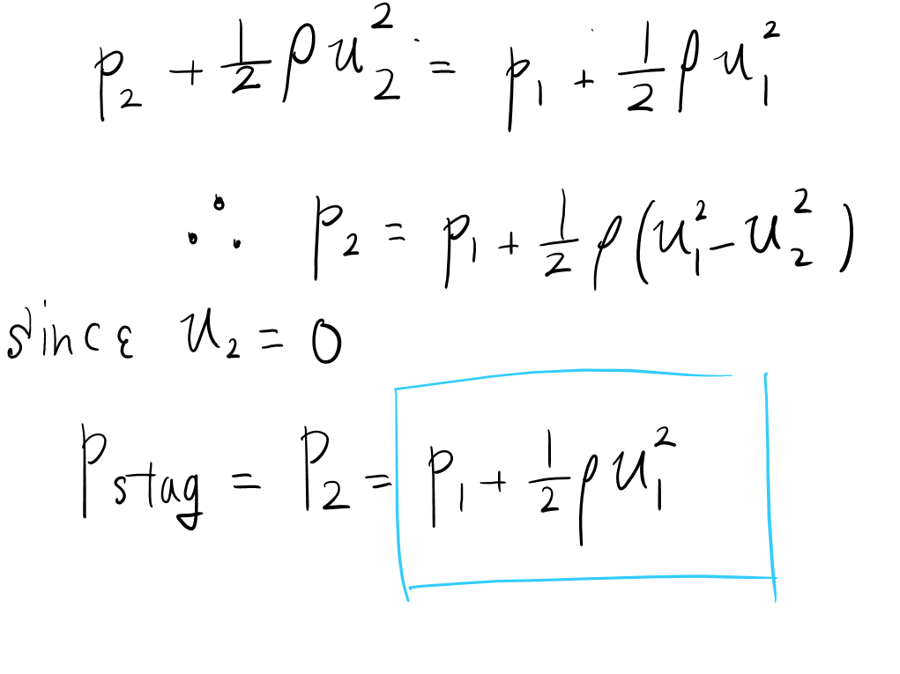

What is the difference between and called?

Answer: relative pressure

Is larger or smaller than , and why would you expect or not expect that from a physical point of view?

Answer: From the calculation above p2 is the sum of p1 and the difference of the dynamic pressure, and at the stagnant point the velocity is essentially zero meaning that the dynamic pressure is a positive value which means that p2 is larger than p1. And simply from the principle of Bernoulli’s Equation when the velocity is smaller the pressure becomes larger meaning that at the stagnant point the static pressure p reaches its maximum.

# Step 2: Create a simple velocity measurement device

The body stopping the fluid does not have to be solid—it can also be a static column of fluid (including air). So, if we want to measure the velocity of an airstream, we just need to find a way to bring some of that air to rest. Figure 2 shows a very simple way of doing this.

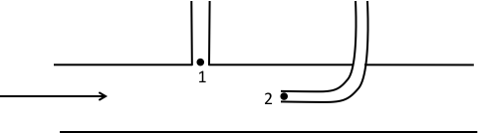



Figure 2: A piezometer and Pitot tube combination

How fast is the fluid moving at point 2?

Answer: At point 2 of the Pitot tube is the stagnant point of the fluid that being where the velocity of the fluid becomes zero.

On Figure 2, shade in the fluid, and indicate its relative height in the two tubes. Which tube is the fluid higher in, and why?

J

Answer: The tube connected with point two will be greater because point 2 is the stagnant point and the velocity becomes zero meaning that the pressure is the maximum. Therefore, the liquid in the tube on the right is pushed to a greater height than the tube on the left.

Now derive an expression for the free stream velocity in the tube, using the pressure measurements at points 1 and 2:

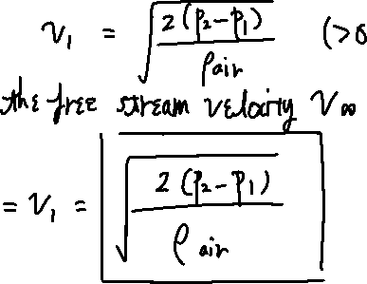

Answer: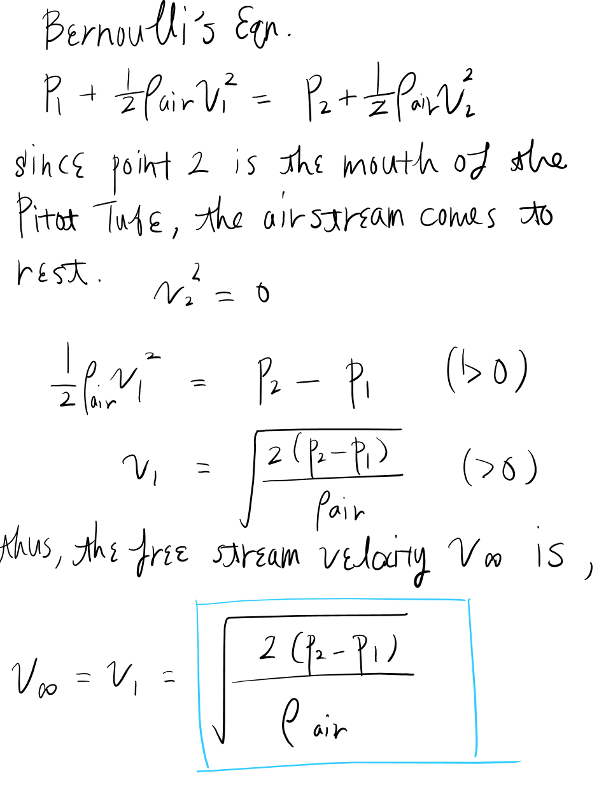

# Step 3: A better device—The Pitot Static Tube

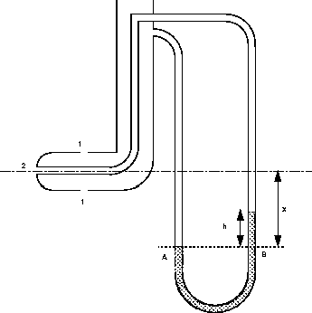

Figure 3: A Pitot Static Tube

Figure 3 shows a slightly more elegant arrangement, where we use a single manometer rather than two piezometers. Write an expression for the free stream velocity in terms of the height difference, *h*, on the figure. Assume that the density of the fluid in the manometer is given by .

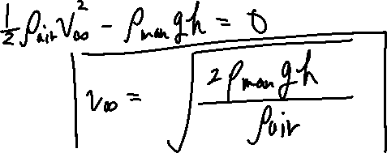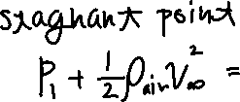

Answer: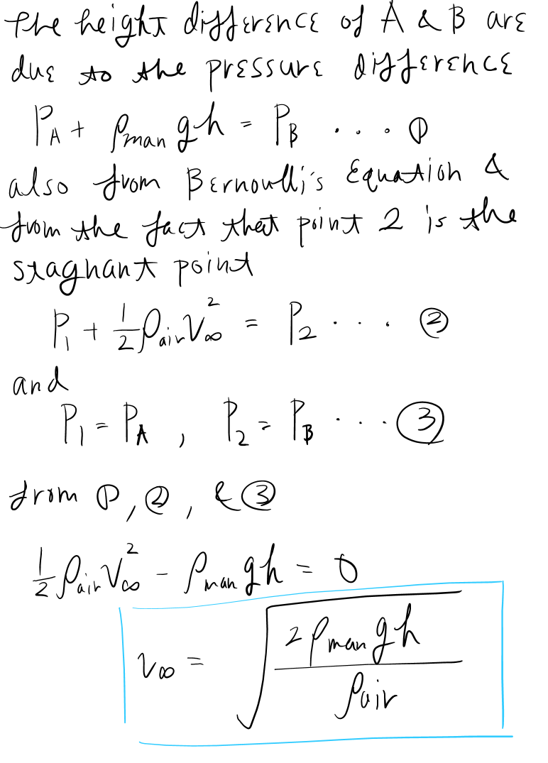

The static Pitot tube has some practical limitations:



At low velocities:

When the velocity is too low the pressure difference in the two tubes become infinitesimal that the error of when measuring the height difference becomes more larger, which interferes with the precision of the experiment.

At supersonic velocities:

If the velocity is too high, that is supersonic, such condition violates the basis or assumption of Bernoulli’s equation and will render the measurement inaccurate in this experiment. Namely, at the front of the tube, in other words at the stagnant point, a shock wave produced by the high velocity will change the total pressure.

In very cold and humid conditions:

In very cold and humid weather conditions the tubes may perhaps become clogged or pinched, and therefore the measured velocity ends up to be incorrect because the resulting pressure is not the total and static pressure of the external flow, which makes it inappropriate to conduct this static pitot experiment at extreme coldness that might cause icing unless there are solutions such as installing heaters on the probes to melt the ice..

# Step 4: Application

Let’s consider now the last set of limitations for pitot tubes—clogging up with ice.

1. An aircraft is performing aerobatic maneuvers when the static port suddenly becomes clogged with ice, unbeknownst to the pilot. If the pilot is in a fast dive, will his airspeed reading be affected, and, if so, how? Explain your answer using appropriate equations.

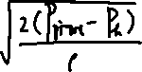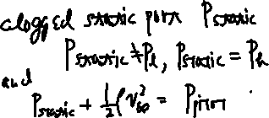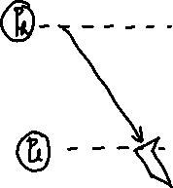

When the static port is clogged and the aircraft descends the static pressure at is stuck at a value at a much higher altitude that is the static pressure is lower than the actual static pressure. Therefore, the difference between the static pressure and the ram pressure becomes larger and the indicated airspeed increases. Practically, the you are flying slower than the indicated airspeed.

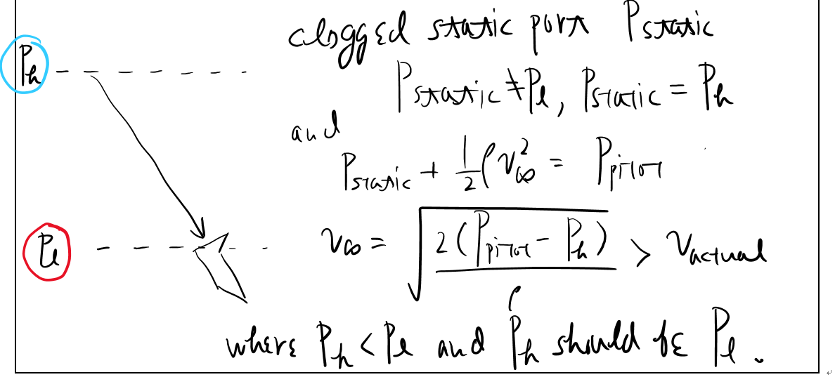

1. The pilot now begins a dramatic climb, still unaware that the static port is clogged. What do you expect the airspeed reading to indicate now?

Opposite of the descending scenario, when the aircraft is climbing the static port is stuck to a pressure that is of low altitude that is a larger value. Thus, the difference between the static pressure and the ram pressure decreases and the indicated airspeed decreases. Hence, practically the aircraft is flying faster than the indicated airspeed.teddsvdvTThe airspeed reading is going to show something that is the opposite of that of the condition of descending, therefore the reading of the airspeed will decrease leaving the aircraft flying faster than the reading since the static pressure is stuck at a lower value.

1. Another pilot at the same ill-fated air show experiences a sudden blockage in her pitot port. If she is accompanying our first pilot on a rapid dive, how would her airspeed reading be affected?

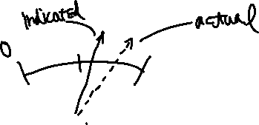

In this scenario the static port is open while the pitot tube is iced. In this case, when descending, the static pressure increases, however the trapped static pressure in the pitot tube becomes smaller than the actual static pressure. Therefore, the difference between the static pressure and the ram pressure becomes smaller and the airspeed indicator starts to slow down. Hence, practically the aircraft will be flying faster than the indicated airspeed.brbeIn this condition the reading is going to be slowing down making the aircraft fly faster than the actual reading. This is because the static pressure in the pitot tube is going to be stuck and the difference between the static port and the pitot tube are going to be smaller.

1. Unbelievably enough, yet another aircraft at the same air show is also having problems. In this case though, the pitot port becomes gradually clogged over the course of the day. How will this pilot’s airspeed reading be affected? Why might landing this aircraft be particularly challenging?

When the pitot tube is gradually becoming clogged, such condition is equivalent to the pitot tube being partially clogged. This is highly problematic in several ways. First, if the front of the pitot tube is clogged and the air drain is still open the airspeed reading will indicate a reading slightly above or below zero making it highly dangerous for the pilot to maneuver through air and, let alone landing. In t

In this condition it is dangerous because the pitot tubes might get clogged partially and that means if the air drain gets drain but the pitot tube is still open the reading of airspeed is almost going to be always close to zero meaning that it will be impossible to know the airspeed of the aircraft.

This means that it will be impossible for the crew to know the speed down of the aircraft hence very difficult to land, in worst case scenario crash.

|  |  |
| --- | --- |
| **Name** | **Team Number** |
| Tomoki Koike | R06 |

**Matlab Assignment**

Write a **Matlab** program to reproduce the standard atmosphere in Appendix B of Anderson. Recreate this data, and also calculate the speed of sound at each altitude. Show your results using a set of appropriate graphs. Show your data in SI and English units. Make sure your graphs are properly labeled.

Use equations from Anderson Ch 3.4. No credit will be given for simply entering the data from the tables. Program your code to produce correctly labeled plots for altitude vs. temperature, pressure, density, and the speed of sound similar to Figure 4 (up to 100,000 ft or 30.48 km).

Your HW file must contain the following:

* This page, with your name filled in.
* Your MATLAB code (including comments).
* A write-up of the formulas you used to create your table.
* A set of graphs showing how pressure, temperature, and density, and the speed of sound vary with altitude, plotted in SI and English units [8 graphs in total].



**Figure 4 Standard Atmosphere temperature model (Brandt, 2004)**